**ACKNOWLEDGEMENT**

We would like to express our gratitude to our honourable Faculty Mr. Zunayeed Bin Zahir for the useful comments, remarks and engagement through the learning process of this project. Also, we would like to thank the participants in our survey, who have willingly shared their precious time during the process of interviewing for suggestions.

We are highly indebted to Mr. Zunayeed Bin Zahir for his guidance and constant supervision as well as for providing necessary information regarding the project & also for their support in completing the project.

We would like to express our gratitude towards our parents & members of Group-6 for their kind co-operation and encouragement which helped us in completion of this project.

**TABLE OF CONTENT**

|  |  |
| --- | --- |
| **1. ABSTRACT** | **3** |
| **2. INTRODUCTION** | **3** |
| **3. PROBLEM STATEMENT** | **4 , 5** |
| **4. BLOCK DIAGRAM** | **5** |
| **5. LITERATURE REVIEW** | **6** |
| **6. TARGET USER** | **7** |
| **7. USER STUDY** | **8** |
| **8. HARDWARE IMPLEMENTATION** | **9 , 10** |
| **9. SOFTWARE IMPLEMENTATION** | **11** |
| **10. METHODOLOGY** | **12** |
| **11. APPLICATIONS** | **12** |
| **12. DEMONSTRATION** | **13 , 14** |
| **13. CHALLENGE** | **15** |
| **14. RESULTS** | **15** |
| **15. CONCLUSION** | **16** |
| **16. REFERENCE** | **17** |
| **17. APPENDIX** | **18, 19, 20, 21, 22, 23, 24** |

**1. ABSTRACT**

Our target is to present an omnidirectional sonar vision device that can assist visually impaired individuals. It will provide autonomous navigation for an unknown environment. The device will use multiple sonar sensors with prior calibration and detects static and dynamic obstacles. It estimates the most intended path based on visual sonar beams in all directions of the individual and provide results in the form of vibration through vibrators fixed around the head. The more closer an individual gets to an obstacle the more intense the vibration gets. We shall present a wearable and portable assistive devices for visually-impaired people in order to show the progress in assistive technology for this group of people.

**Key Words:** SONAR SENSORS, ARDUINO UNO, NAVIGATION, GOOGLE ASSISTANT, IFTTT SERVER

**2. INTRODUCTION**

Portability of visually impaired people is confined by within their surroundings. Moving safely and confidently in a metropolitan area without any human assistance is a tedious work for vision loss people. This paper proposes theoretical model and a system concept to provide an electronic aid for visually impaired people. This work rely on developing a gadget that is, sonar sensors attached to an Arduino Uno and a Bluetooth headset (wearable) connected to a mobile device, for blind people that helps them to find their way in this world. The Internet Of Things is a intercommunication between various systems where the communication is being carried by means of network or some of signals. The current position of the vision loss humans can be found by using Global Positioning System (GPS) which is embedded in the mobile device. The headset and the proposed device are paired using WIFI and Bluetooth. Thus IOT help blind people to find their way back home by the communication between the walking stick and the headset, which are Bluetooth, paired and enable the communication between devices.

**3. PROBLEM STATEMENT**

Around the world, Blind people face real problems. Their major problem lies in their sense of disability and sees what around them. Also they face a problem with other people hesitate in their service or assistance to them. In addition many people do not know how to deal with blind person. Blind people needs a boost of confidence in their self and their ability to achieve anything and rely on their self without the needs of others [3]. Many countries developed many mechanisms of services that contribute to make life easier for the blind, where they developed some rules and laws in the art of dealing with the blind without notifying disability and some companies and organizations are training and recruiting people with the ability to deal with blind. In addition, there are a lot of companies have developed special equipment used by the blind to help them [2]. There are a lot of emotions a blind person hides behind his eyelids that we cannot see them. Many of them feel embarrassed to talk about their suffering in front of others or feel upset at their inability to see because of their illness or old age or the events that he suffered and caused him to lose sight. Some diseases that cause weakness in sight are listed,

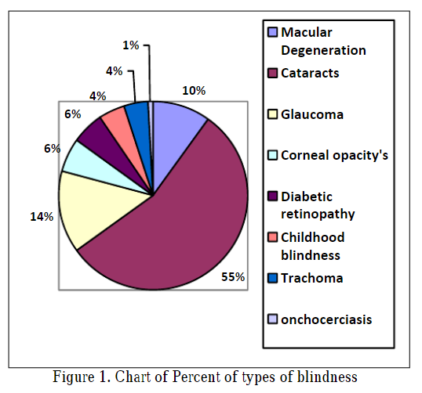

According to the World Health Organization in 2018 for the most common reasons of blindness (except for refractive errors): 1. Cataracts (47.9%), 2. Glaucoma (12.3%), 3. Macular Degeneration (8.7%), 4. Corneal opacities (5.1%), 5. Diabetic retinopathy (4.8%), 6. Childhood blindness (3.9%), 7. Trachoma (3.6%) 8. Onchocerciasis (0.8%) [4]. MacularDegeneration CataractsGlaucomaCorneal opacity's Diabeticretinopathy Childhoodblindness Trachoma onchocerciasisFigure 1. Chart of Percent of types of blindness Blindness can be divided into several types [4]: 1. Partial blindness. 2. Blindness as a result of the incident. 3. Color blindness. 4. Psychological blindness. Therefore, the prevalence of different types of blindness is difficult to assess because of the retinal differences between people this led to a lot of scientists to try to find different ways to solve this crisis. And this suffering as blindness varies by categories as mentioned some of them is suffering from blindness only in old age. Some of them is infected since the births and other are blind in addition to deafness and inability to listen even for high voices. Some of blind people hires someone to be his assistant and assist him in his movement. In addition to using movement assistant to navigate or use trained dogs for this purpose. Thus, it is do not hide the extent of the suffering blind face behind their inability to see or the suffering of people around them. Many of those who help people blind feel bothers with the blind people and their special needs. Therefore, they should be find new style to help blind and rely on their self without resorting to other people [2].

**4. BLOCK DIAGRAM**

Figure 1 shows the block diagram of the proposed Movement Assistant for Vision Impaired using Echo Location. In this system, the sensor will send ultrasonic sounds, which later will be sent back if there is an obstacle in front of the person. The signal will be transferred to the Arduino which will process the distance and later send vibration alerts to the user/person.

To turn on/off the device we are using google assistant. Sending a voice command, “Turn on Movement Assistant” to the mobile device will automatically turn on/off the device. Moreover, we can use Google Navigation to travel from one destination to another.

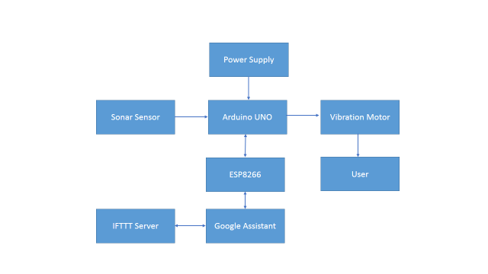

Fig- 1: Block diagram of "Vision Impaired Wearable Movement Assistant Using Echo Location"

**5. LITERATURE REVIEW**

There are a lot of devices which assist the visually challenged for navigation indoor and outdoor. All these devices rely mainly on Global Positioning System (GPS) alone, to navigate around. A Movement Assistant System for Visually Impaired. The above paper proposes a system utilizes vision, surrounding processing methodology and a sonification procedure to support blind navigation. The developed system includes a wearable sonar sensor, Arduino and Wi-Fi module with earphones. Wahab et al. studied the development of the Smart Cane product for detecting the objects and produce accurate instructions for navigation [19]. The Smart Cane was presented originally by Central Michigan University’s students. The design of the Smart Cane is shown in Figure 2. It is a portable device that is equipped with a sensor system. The system consists of ultrasonic sensors, microcontroller, vibrator, buzzer, and water detector in order to guide visually-impaired people. It uses servo motors, ultrasonic sensors, and fuzzy controller to detect the obstacles in front of the user and then provide instructions through voice messages or hand vibration. The servo motors are used to give a precise position feedback. Ultrasonic sensors are used for detecting the obstacles. Hence, the fuzzy controller is able to give the accurate decisions based on the information received from the servo motors and ultrasonic sensors to navigate the user.

The output of the Smart Cane depends on gathering the above information to produce audio messages through the speaker to the user. In addition, hearing impaired people have special vibrator gloves that are provided with the Smart Cane. There is a specific vibration for each finger, and each one has a specific meaning.

The Smart Cane has achieved its goals in detecting the objects and obstacles, producing the needed feedback. As shown, the Smart Cane is easily carried and easily bent. In addition, the water sensor will not detect the water unless it is 0.5 cm or deeper and the buzzer of water detector will not stop before it is dried or wiped. The authors of the paper have some recommendations for the tested system. They stated that in order to monitor the power status, it would better to have a power supply meter being installed. The authors recommended adding a buzzer timer to specify the period to solve the buzzer’s issue as well.

**6. TARGET USER**

Many countries developed many mechanisms of services that contribute to make life easier for the blind, where they developed some rules and laws in the art of dealing with the blind without notifying disability and some companies and organizations are training and recruiting people with the ability to deal with blind. In addition, there are a lot of companies have developed special equipment used by the blind to help them [2].There are a lot of emotions a blind person hides behind his eyelids that we cannot see them. Many of them feel embarrassed to talk about their suffering in front of others or feel upset at their inability to see because of their illness or old age or the events that he suffered and caused him to lose sight. Some diseases that cause weakness in sight are listed (Fig.1), according to the World Health Organization in 2018 for the most common reasons of blindness (except for refractive errors):

Blindness can be divided into several types [4]:

1. Partial blindness.

2. Blindness as a result of the incident.

3. Color blindness.

4. Psychological blindness.

Therefore, the prevalence of different types of blindness is difficult to assess because of the retinal differences between people this led to a lot of scientists to try to find different ways to solve this crisis. And this suffering as blindness varies by categories as mentioned some of them is suffering from blindness only in old age. Some of them is infected since the births and other are blind in addition to deafness and inability to listen even for high voices.

**7. USER STUDY**

There will sonars in six direction which will cover 360˚. The sensors will be in such angle so that there will be created a circle of ultrasonic waves around the user which will cover from his neck to toe. To sense the location of the object there will be small vibration motor in six direction also. So that the user can get clear sense about the object’s location. If the object is moving vibration motor will vibrate according to the direction. There will be extra 1 sonar at vertical direction to cover user’s head at straight direction. There will be extra 2 vibration motor one could be placed in user belt which will only vibrate when there will be any object at middle direction. Thinking of railway gate/parking gate. Only for those type of object, this motor will vibrate. The other vibration is for any hole ahead of user or think about stairs.

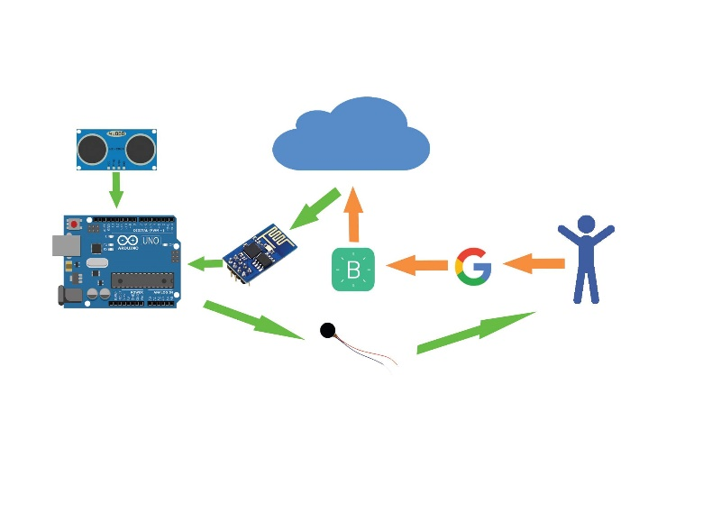

The user will be notified if there is hollow ahead of him. Could be placed in hand. There will be a mobile app along with the hardware which will start by voice command of the user, it will be able to set destination, provide voice assistant for walking etc. Two bone conduction speaker will be provided behind the ear of the user (similar to Zungle Smart sunglass). These speakers will be attached with the main device. Most importantly as our sensors will be placed in an angle so that the app will be able to take base range for the sonar automatically. May be 30 sec of standing still after giving voice command for example: “Set my base range”. There could be one question “What will happen if the user sits after activating the project as there is a vibration function for middle range?” Yeah there will be a command for that, like if the user say “I am sitting right now” the vibration will be turned off.

**8. HARDWARE IMPLEMENTATION**

* ➢SONAR SENSORS
* ➢VIBRATION MOTORS
* ➢ARDUINO
* ➢8266 WIFI MODULE
* ➢POWER SUPPLY
* ➢WIRES
* ➢BREAD BOARD

**SONAR SENSORS**: Work on the principle of reflected sound waves and are used to measure distance. One sensor can detect others operating nearby. Sound waves are emitted by the ultrasonic sensor and they’re reflected back if there is an object in front of it. The sensor detects these waves and measures the time it takes between transmitting and receiving those sound waves. Distance is then estimated by the time interval between sensor and object.

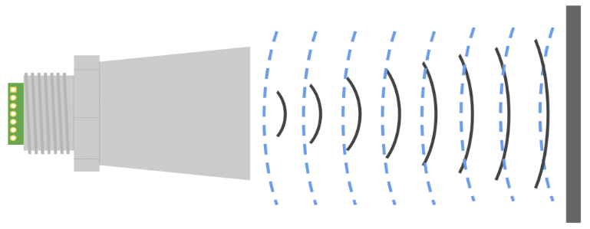

**VIBRATION MOTORS:** An eccentric rotating mass vibration motor (ERM) uses a small unbalanced mass on a DC motor when it rotates it creates a force that translates to vibrations. A linear resonant actuator (LRA) contains a small internal mass attached to a spring, which creates a force when driven.

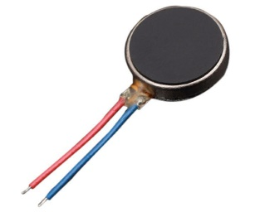

**ARDUINO:** Arduino is an open-source hardware and software company, project and user community that designs and manufactures single-board microcontrollers and microcontroller kits for building digital devices and interactive objects that can sense and control both physically and digitally.

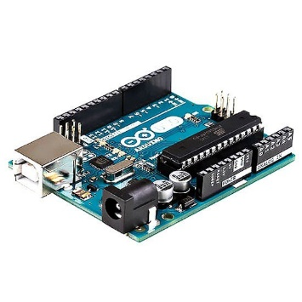

**8266 WIFI MODULE:** The ESP8266 is a low-cost Wi-Fi microchip with full TCP/IP stack and microcontroller capability produced by manufacturer Espressif Systems in Shanghai, China.

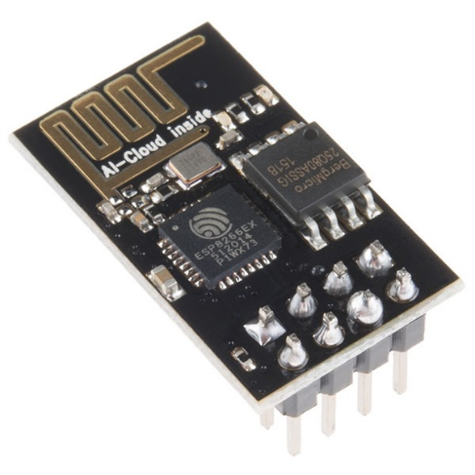

**POWER SUPPLY:** Can be defined as portable batteries that use circuitry to control any power in and power out. They can charged up using a USB charger when power is available, and then used to charge battery powered items like mobile phones and a host of other devices that would normally use a USB charger.

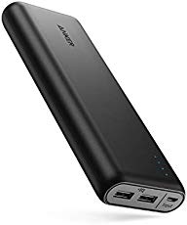

**9. SOFTWARE IMPLEMENTATION**

**ARDUINO IDE**

The Arduino integrated development environment (IDE) is a cross-platform application (for Windows, macOS, Linux) that is written in the programming language Java. It is used to write and upload programs to Arduino compatible boards, but also, with the help of 3rd party cores, other vendor development boards.

The source code for the IDE is released under the GNU General Public License, version 2. The Arduino IDE supports the languages C and C++ using special rules of code structuring. The Arduino IDE supplies a software library from the Wiring project, which provides many common input and output procedures. User-written code only requires two basic functions, for starting the sketch and the main program loop, that are compiled and linked with a program stub main() into an executable cyclic executive program with the GNU toolchain, also included with the IDE distribution. The Arduino IDE employs the program argued to convert the executable code into a text file in hexadecimal encoding that is loaded into the Arduino board by a loader program in the board's firmware.

**IFTTT**

If This Then That, also known as IFTTT, is a free web-based service to create chains of simple conditional statements, called applets. An applet is triggered by changes that occur within other web services such as Gmail, Facebook, Telegram, Instagram, or Pinterest. It is basically used to set up any command over the google assistant to turn on and off the app. Following some series of steps we can complete the process of setting the commands. We will need to over an account in the IFTTT server at first ti establish this process,

**10. METHODOLOGY**

The work of electronic parts distributed in figure. Ultrasonic sensor works as input device which sends data of objects around to Arduino for processing and sentencing which respond should give Arduino command vibration motor, which work as output device to respond through, gives vibration alarm.

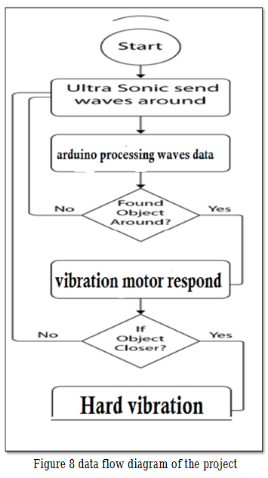

**11. APPLICATIONS**

* Determining obstacles around the user body from the ground to the head
* Providing information about the distance between the user and the obstacle with essential vibrating intensity
* Affording information to give the ability of self-orientation and mental map of the surroundings
* Providing mobility instructions and paths to guide the user and develop her/his brain about the environment.
* Google navigation to a specific address or location by using headphones

**12. DEMONSTRATION**

6 sonar sensors will be attached to the blind user’s body as shown below:

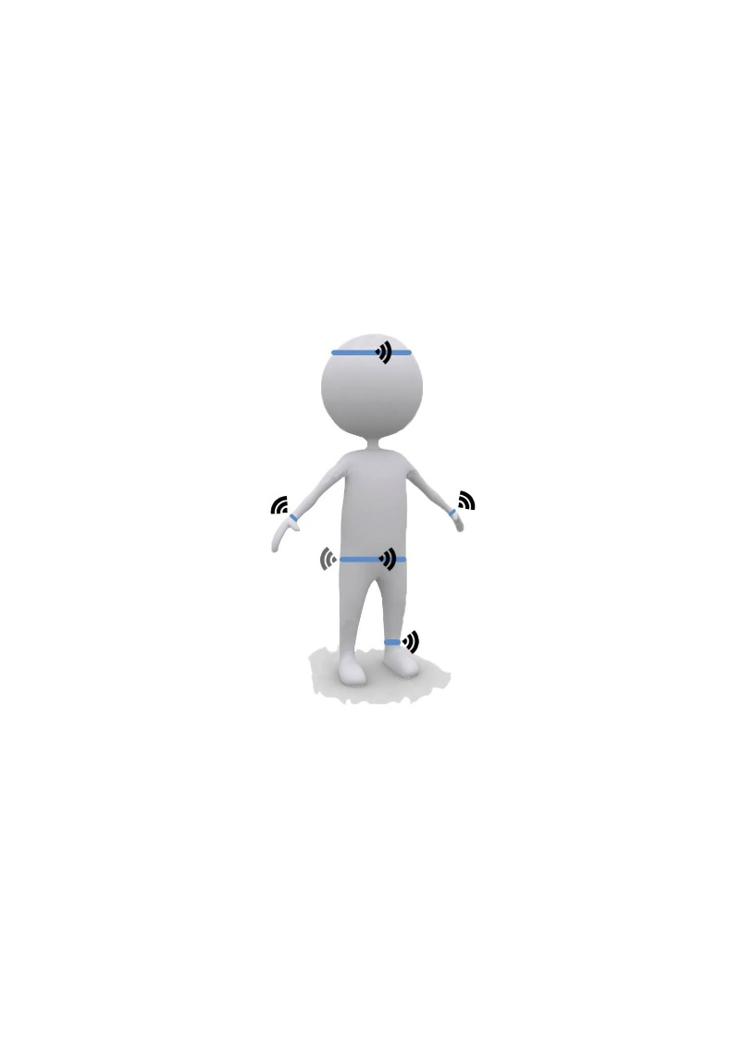

We shall use google assistant to turn on/off the device by using a voice command, “Turn On Movement Assistant.”Google Assistant is an artificial intelligence-powered virtual assistant developed by Google that is primarily available on mobile and smart home devices. Unlike the company's previous virtual assistant, Google Now, Google Assistant can engage in two-way conversations.

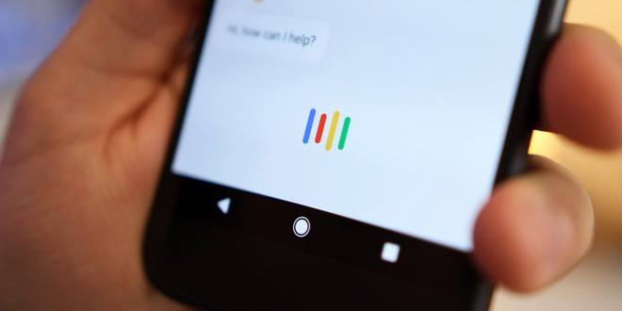

The visually impaired person can navigate from one place to another by using google navigation connected to a Bluetooth headphone. Google Maps is a great app, but it requires a constant data connection, and that's not ideal if you're traveling outside cities, where data connections can be sparse. The good news is that there are ways to get around that.

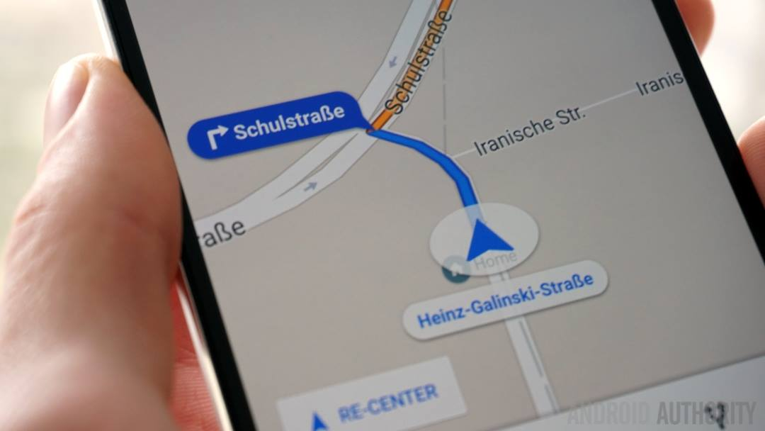

Although a number of electronic travel aids that utilize sonar have been developed none appear to be in common use, and very few provide information other than range finding or a processed localization cue. In our project we proposed a device help detect visually impaired people from obstacle. Our system is designed keeping in mind that users are visually impaired people, the information representation is simple. By using this device they feel confident and they can easily move from one place to another by their own. This article presents the modern assistive technologies for visually impaired people in the area of computer vision, embedded system, and mobile platforms

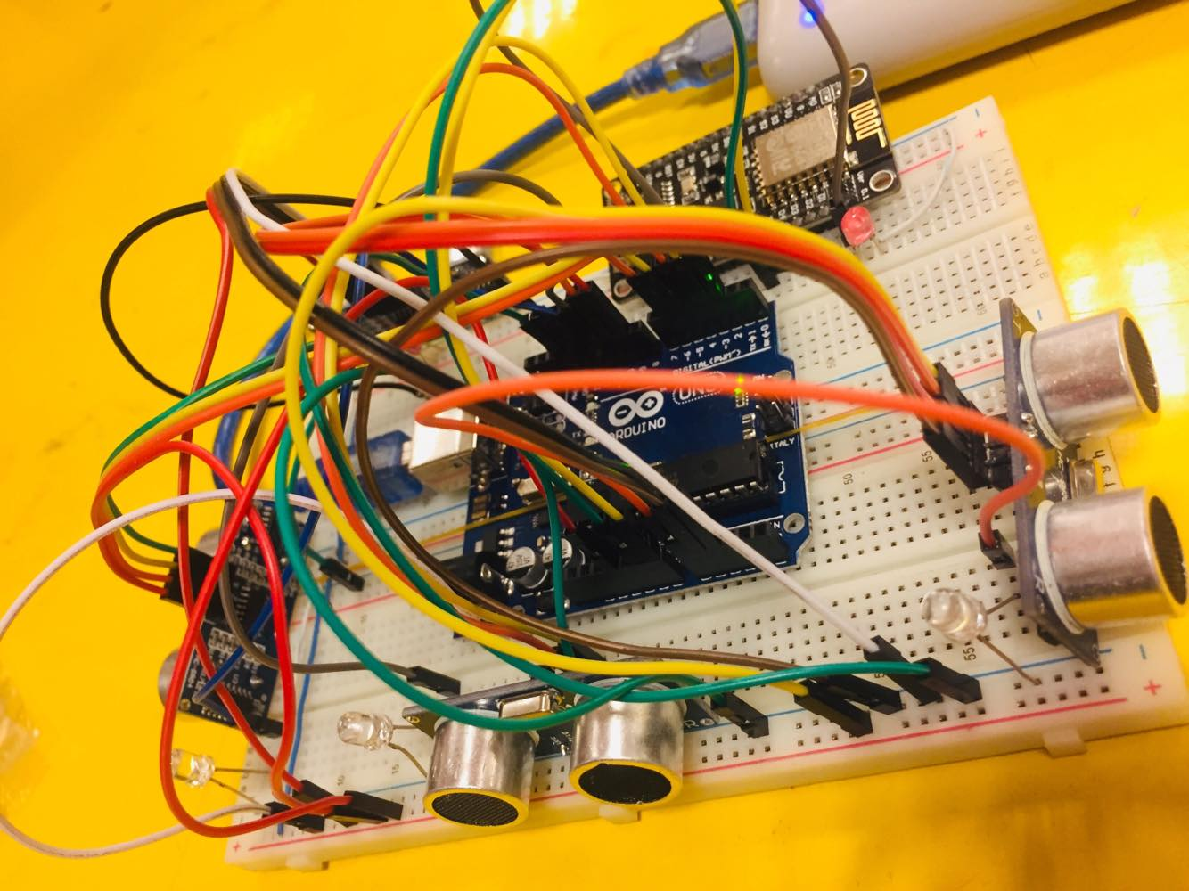

**13. CHALLENGE**

Our device has to be user friendly for those who is visually impaired. Firstly the system needs to provide a fast processing for the exchanged information between the user and sensors. To operate the device visually impaired people need some practice to understand the distance of any obstacles through the intensity of vibration. In our future implementation we will connect our device with the GPS so that visually impaired people can set their destination and detect current location through their voice command so that it will be very easy to operate and set automated for different users.

**14. RESULTS**

The overall result of the experiment , came as follows:

i. The highest response was whenever it is closer to the object.

ii. Middle respond was found in middle distance from the object.

iii. No respond where found on far distance. Table contains numerical minutes of the experience on the gloves and it shows the results in cm unity:

|  |  |
| --- | --- |
| **OBSTACLES** | **TEST** |
| FROM 0 cm to 10 cm | HARD VIBRATION |
| FROM 10 cm to 20 cm | MEDIUM VIBRATION |
| FROM 20 cm to 30 cm | LOW VIBRATION |
| ABOVE 30 cm | NO VIBRATION |

**15. CONCLUSION**

Our target is to present an omnidirectional sonar vision device that can assist visually impaired individuals. It will provide autonomous navigation for an unknown environment. The device will use multiple sonar sensors with prior calibration and detects static and dynamic obstacles. It estimates the most intended path based on visual sonar beams in all directions of the individual and provide results in the form of vibration through vibrators fixed around the head. The more closer an individual gets to an obstacle the more intense the vibration gets. We shall present a wearable and portable assistive devices for visually-impaired people in order to show the progress in assistive technology for this group of people. Although a number of electronic travel aids that utilize sonar have been developed none appear to be in common use, and very few provide information other than range finding or a processed localization cue. There will sonars in six direction which will cover 360˚. To sense the location of the object there will be small vibration motor in six direction also. So that the user can get clear sense about the object’s location. If the object is moving vibration motor will vibrate according to the direction. There will be extra 1 sonar at vertical direction to cover user’s head at straight direction. There will be extra 2 vibration motor one could be placed in user belt which will only vibrate when there will be any object at middle direction. Thinking of railway gate/parking gate. Only for those type of object, this motor will vibrate. The other vibration is for any hole ahead of user or think about stairs. The user will be notified if there is hollow ahead of him. In our project we proposed a device help detect visually impaired people from obstacle. Our system is designed keeping in mind that users are visually impaired people, the information representation is simple. By using this device they feel confident and they can easily move from one place to another by their own. This article presents the modern assistive technologies for visually impaired people in the area of computer vision, embedded system, and mobile platforms. The goals of the developed system are to generate an audio signal and/or vibration with the presence of obstacles for indoor and outdoor surroundings. Although all the studied tools are in their early stages, many of them are interpreted into everyday life with the use of recent technologies (i.e., mobile phones). On the basis of the review, sufﬁcient explanation of the major features that should be incorporated in any framework that can assist visually impaired people is provided. Evidently, the actual goal is achieved when physicians and computer scientists develop an assistive technology for visually impaired people in the future. Hopefully, this review will assist researchers who are enthusiastic in developing movement assistants for visually impaired people in the future.

**16. REFERENCE**

1. https://www.ncbi.nlm.nih.gov/pmc/articles/PMC5375851/

2. https://www.researchgate.net/publication/330078108_Developing_Walking_Assistants_for_Visually_Impaired_People_A_Review

3. https://ifttt.com/

4. https://www.arduino.cc/

5. https://www.emeraldinsight.com/doi/abs/10.1108/LHTN-11-2017-0083

6. https://www.researchgate.net/publication/261114183_Smart_guide_for_blind_people

7. https://arxiv.org/ftp/arxiv/papers/1609/1609.01409.pdf

8. https://www.afb.org/research-and-initiatives/education/education-initiatives-afb/educating-blind-and-visually-impaired

9. https://www.researchgate.net/publication/228781072_An_Electronic_Travel_Aid_for_Blind_People

10. https://www.researchgate.net/publication/300344608_ULTRASONIC_SENSORS_GLOVES_FOR_BLIND_PEOPLE_USING_LILYPAD_ARDUINO

11. https://arxiv.org/ftp/arxiv/papers/1709/1709.09359.pdf

12. https://online-journals.org/index.php/i-joe/article/viewFile/7565/4676

13. http://oxfordre.com/socialwork/view/10.1093/acrefore/9780199975839.001.0001/acrefore-9780199975839-e-37

14. https://www.hindawi.com/journals/abb/2015/479857/

15. https://nfb.org/images/nfb/publications/fr/fr5/issue1/f050113.html

16. http://www.robotica-up.org/PDF/Wearable4Blind.pdf

**17. APPENDIX**

• SSOP -Shrink small-outline package

• Electrostatic Discharge (ESD): A subclass of electrical overstress which may cause immediate device failure, permanent parameter shifts and latent damage causing increased degradation rate

**TOTAL CODE**

**SETTING UP BLINK APP**

#define BLYNK_PRINT Serial

#include <ESP8266WiFi.h>

#include <BlynkSimpleEsp8266.h>

// You should get Auth Token in the Blynk App.

// Go to the Project Settings (nut icon).

char auth[] = "adca6458a1da43fd9b462221a82c4d90";

// Your WiFi credentials.

// Set password to "" for open networks.

char ssid[] = "Moin";

char pass[] = "102030406";

//define all the pins

int blynkPin=16;

void setup(){

Serial.begin(9600);

Blynk.begin(auth, ssid, pass);

}

void loop()

{

Blynk.run();

}

**SETTING UP CODE FOR SONAR SENSORS TO PROCESS DATA IN ARDUINO**

int trigPin1=4;

int echoPin1=3;

int vibration1=11;

int trigPin2=6;

int echoPin2=5;

int vibration2=12;

int trigPin3=15;

int echoPin3=16;

int vibration3=13;

int trigPin4=10;

int echoPin4=9;

int vibration4=14;

void setup(){

Serial.begin(9600);

pinMode (2,INPUT);

pinMode(trigPin1, OUTPUT);

pinMode(echoPin1, INPUT);

pinMode(vibration1, OUTPUT);

pinMode(trigPin2, OUTPUT);

pinMode(echoPin2, INPUT);

pinMode(vibration2, OUTPUT);

pinMode(trigPin3, OUTPUT);

pinMode(echoPin3, INPUT);

pinMode(vibration3, OUTPUT);

pinMode(trigPin4, OUTPUT);

pinMode(echoPin4, INPUT);

pinMode(vibration4, OUTPUT);

}

void loop(){

if(digitalRead(2)==HIGH){

Serial.println("wala");

long duration1, distance1;

digitalWrite(vibration1, LOW);

digitalWrite(trigPin1, LOW);

delayMicroseconds(2);

digitalWrite(trigPin1, HIGH);

delayMicroseconds(10);

digitalWrite(trigPin1, LOW);

duration1 = pulseIn(echoPin1, HIGH);

distance1 = (duration1/2) / 29.1;

if (distance1 >= 30 || distance1 <= 0){

Serial.println("Out of range");

digitalWrite(vibration1, LOW); }

else {

Serial.print ( "Sensor1 ");

Serial.print ( distance1);

Serial.println("cm");

digitalWrite(vibration1, HIGH);

}

delay(10);

long duration2, distance2;

digitalWrite(vibration2, LOW);

digitalWrite(trigPin2, LOW);

delayMicroseconds(2);

digitalWrite(trigPin2, HIGH);

delayMicroseconds(10);

digitalWrite(trigPin2, LOW);

duration2 = pulseIn(echoPin2, HIGH);

distance2= (duration2/2) / 29.1;

if (distance2 >= 30 || distance2 <= 0){

Serial.println("Out of range");

digitalWrite(vibration2, LOW);

}

else {

Serial.print("Sensor2 ");

Serial.print(distance2);

Serial.println("cm");

digitalWrite(vibration2, HIGH);

}

delay(10);

long duration3, distance3;

digitalWrite(vibration3, LOW);

digitalWrite(trigPin3, LOW);

delayMicroseconds(2);

digitalWrite(trigPin3, HIGH);

delayMicroseconds(10);

digitalWrite(trigPin3, LOW);

duration3 = pulseIn(echoPin3, HIGH);

distance3= (duration3/2) / 29.1;

if (distance3 >= 30 || distance3 <= 0){

Serial.println("Out of range");

digitalWrite(vibration3, LOW);

}

else {

Serial.print("Sensor3 ");

Serial.print(distance3);

Serial.println("cm");

digitalWrite(vibration3, HIGH);

}

delay(100);

long duration4, distance4;

digitalWrite(vibration4, LOW);

digitalWrite(trigPin4, LOW);

delayMicroseconds(2);

digitalWrite(trigPin4, HIGH);

delayMicroseconds(10);

digitalWrite(trigPin4, LOW);

duration4 = pulseIn(echoPin4, HIGH);

distance4= (duration4/2) / 29.1;

if (distance4 >= 30 || distance4 <= 0){

Serial.println("Out of range");

digitalWrite(vibration4, LOW);

}

else {

Serial.print("Sensor4 ");

Serial.print(distance4);

Serial.print("cm");

digitalWrite(vibration4, HIGH);

}

delay(10);

}else{

digitalWrite(vibration1, LOW);

digitalWrite(vibration2, LOW);

digitalWrite(vibration3, LOW);

digitalWrite(vibration4, LOW);

}

delay(30);

}